Covid-19 (Corona Virus Risk Management Framework
Risk management is being aware of all potential material risks within a business environment and having a plan, responsibilities for and accountability of those risks. During times of business shocks, such as medical epidemics, risk can be identified within a business in many areas. For instance, how will the event affect your customers, suppliers, employees, supply chains, access to capital and how long will the issue likely affect your business. These risk areas can be summarised below and not exhaustive:
Risk Area | Example Risks
Financial risk | Liquidity, solvency, net margins, business health, poor returns on investment, financial structure imbalances,
Market risk | Market collapse, demand reductions
Reputational risk | Poor media publicity, news detrimental to your business, local area, staff
Operational risk | Supply chain collapse, employee shortages
People risk | Loss of employees through prolonged illness, safety and security of your place or work and minimising risk of infection,

The risk management framework is summarised in the below diagram:
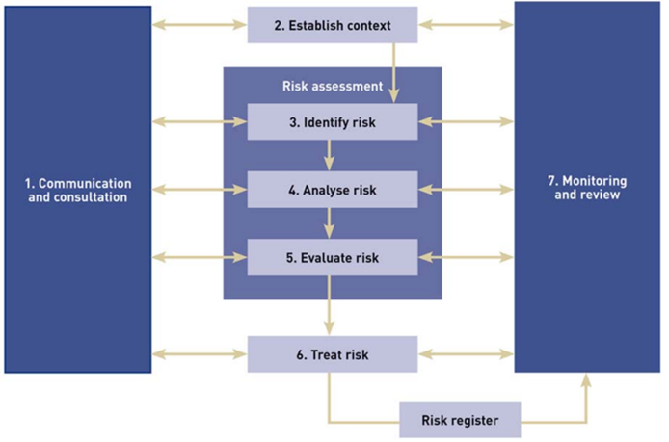
This document aims to provide some areas where all businesses can assess the common risks, and add to their individual risk matrix.
Below is a sample risk register. Use this to identify your business risks, as well as understand their impact and likelihood of occurring. Once complete, transfer these to the matrix below to understand what risks need managing more urgently. For a more detailed framework, check the ISSO 31000 ANZ standards for your business.
Risk Assessment and Identification
Risk # | Description | Prob % | Impact H/M/L | Impact | Treatment | Risk Classification – see matrix
People and workplace Risk
P1 | Internal Communications: Will employee movement/interaction/communication | 80% | H | increase risk of infection to employee  Confusion increases tress, reduces working effectivness | Increase video meetings internally immediately and for the foreseeable future. Implement a work from home policy | Critical Risk
P2 | Fixtures and fittings: What types of fittings do you have and are they carrying risk (e.g. hard to clean soft furnishings)?
P3 | Client and supplier meetings: Will the number of staff interacting physically with customers increase your risk? (e.g. phone/web, reduce frontline staff)
P4 | Physical location proximity: How risky are your neighbours (e.g. next to a GP office/Pharmacy)? Can you reduce your exposure to risky neighbours?
P5 | Environmental risk: Is your workplace hygiene adequate to reduce risk (e.g. antibacterial wipes/hand wash, safety gear requirements)?
P6 | Travel Risk: Do you know understand travel plans of by staff (any high-risk travel)?
P7
P8
P9
P10
Operational risk
O1 | Can your business function if people cannot travel to your workplace? (work from home plans / key people plans ?)
O2 | Employee infection confirmed in business premises – shutdown needed (who/what/where/how long)
O3 | Communications in case of shutdown – employees / customers / suppliers
O4 | Following end of infection risk – What risks are inherent in reopening location?
O5 | Indirect shutdown risk – ie schools and loss of workers through indirect 3rd party closures
O6 | Worker’s rights and employer obligations for enforced shutdown
O7 | Security of your supply chains
O8 | Alternate suppliers and risk
O9 | Supply Chain lead time delays
O10 | Panic buying of supplies critical to your business
Market Risk
M1 | Is there a risk of market collapse?
M2 | What market slowdown foreseen?
M3 | Risk of enforced unit price changes?
M4 | Disrupting technologies – will new tech change your market and take advantage of Covid-19
M5 | Change of consumer behavior long term risk
M6
M7
M8
M9
M10
Financial Risk
F1 | Working capital risk – How long is your runway?
F2 | Access to short term working capital
F3 | Business model risk – do you have recurring and stable revenues v one off purchases?
F4 | Customer risk – are your customers likely to withstand the virus?
F5 | Flexibility of creditor payment terms and client receipt terms
F6 | Loans and long term finance – flexibility of terms / renegotiation possibilities
F7 | Inventory management risk – need to safeguard supplies v need to reduce capital tied up in stock
F8 | Workforce agreements risk – inflexible ? can you dictate a 3 or 4 day week and reduced working times to maintain working capital
F9
F10
Reputational Risk
R1 | High Profile Workplace infection
R2 | Client Communication Mishandling
R3 | Market collapse handling
R4 | Stock Market Communications
R5 | Reduced service client communications
R6 | Financial standing communications
R7
R8
R9
R10
Other Non Classified Risks
OTH1
OTH2
OTH3

 | Risk Management Matrix
 | PROBABILITY
IMPACT | 5 | 0-50% | 51-60% | 61-70% | 71-85% | 86-100%
 |  |  |  |  | P1
 | 4
 | 3
 | 2
 | 1

Medium Risk High Risk Critical Risk

Risk Treatment Plan
Risk # | Description | Mitigation | Specific Actions Needed | Responsible Party | Date for completion
Critical Risks
P1 | Risk of infection from internal communications | Reduce face to face meetings | Communication to all staf banning face to face meetings internallu
High risk
Medium Risk
Other risks that need planning

